LEIAS educational services –

mission statement and HISTORY
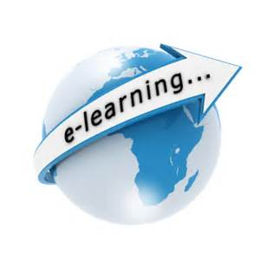  Who are LEIAS Educational Services?  LEAIS is a new full-service Educational Services with the goal to work with schools and universities in the USA and around the world. Our four main services are to do the following within the next 5 years:  • To develop a program that integrates touring to the USA with English Language instruction,  • To provide invaluable resources to English Language learners for finding the best materials on the web for free or for a minimal free to save schools, universities and students invaluable time and energy searching for the best quality websites, |  | • To offer professional resume services and editing services of academic papers written by non-native English speaking people,  • To offer tutoring instruction for GED and TESOL (Teaching English as a Second Language), to open up a tutoring center, and offer grants for those who pass the GED or TESOL tests to encourage Educational Excellence and English Language proficiency in the USA.  Our other services include the following:  • Free group English Language instruction on Facebook.  • Free forums on English language learning and teaching on Facebook.  • Free grammar and language teaching and learning advise.  To register for membership and to learn more, go here: https://www.facebook.com/learnenglishinasnap/app_106171216118819

